|  |
| --- |
|  |
| SRU232- BLE Module Range Analysis |
| Version 01.01.05 |



**Revision History**

|  |  |  |  |
| --- | --- | --- | --- |
| **Version #** | **Remark** | **Date** | **Done By** |
| 01.01.01 | Initial Release | 26th May,2015 | Kinjal |
| 01.01.02 | Updating Testing Procedure | 10th June,2015 | Kinjal |
| 01.01.03 | Add testing procedure in chapter #5. | 11th June,2015 | Kinjal |
| 01.01.04 | Add Results detail | 15th June,2015 | Kinjal |
| 01.01.05 | Update Results and add testing procedure in Chapter #6 | 16th June,2015 | Kinjal |
|  |  |  |  |
|  |  |  |  |
|  |  |  |  |
|  |  |  |  |

# Table of Contents

1. Introduction 4

2. Definition(s) and Abbreviation(s) 5

3. Reference(s) 5

4. Range test between SRU232 to Mobile for BLE Mode 6

4.1 Requisite items 6

4.2 Testing Procedure 6

4.3 Results 9

5. Range test between SRU232 to SRU232 (ANT Mode) 10

5.1 Requisite items 10

5.2 Testing Procedure 10

5.3 Results 12

6. Range test between Module to Module (BLE Mode) 13

6.1 Requisite Items 13

6.2 Testing Procedure 13

6.3 Results 14

# Introduction

2.4 GHz RF signal is strongly affected by any obstacles within the RF path. Thus defining a range for a Bluetooth device is more or less question of how to determine the range. For example, suppose a radio located in a devices attached with human body then it might be get short range because Human body has strongly affected by the RF field. If the person doesn’t point the device directly to near the transmitter then there are no more chance for body or other obstacles are within the RF path and it will reduce the force for received RF signal.

To determine the range for SRU232 was tested in an airfield using a data connection between the modules. The result does not guarantee practical range for real application. The result should be considered as maximum theoretical range. In a practical application the range can be much shorter because the orientation and height of the antenna can’t be controlled and also typically there are obstacles within the RF path which will attenuate the signal significantly.

In practical application the range is affected by:

* Persons / obstacles moving close to the antenna. This is because of multipath propagation and will have an affected even if the person is not in line of sight between the two radios.
* Any obstacles within the RF path
* PCB layout around the antenna (depending on the type of the antenna)
* The shape of the PCB (depending on the type of the antenna)
* The mechanical design of the end product

Because the range is affected by many factors which are difficult to control, the practical range must be tested with the end product and the application should not be design based on the maximum theoretical range because the practical range will always be shorter.

Following chapter shows how the transmit power, receiver sensitivity and the radiation pattern converts to link budget and how the line of sight range can be estimated using plane earth loss calculation. Also the practical test results are shown to compare with the theoretical estimate.

# Definition(s) and Abbreviation(s)

|  |  |
| --- | --- |
| **Name** | **Abbreviation** |
| RF | Radio Frequency |
|  |  |
|  |  |
|  |  |

Table

# Reference(s)

|  |  |
| --- | --- |
| **Document #.** | **Title** |
| 1 | SRU 232_01.01.02.xls |
|  |  |
|  |  |
|  |  |

Table

# Range test between SRU232 to Mobile for BLE Mode

## 4.1 Requisite items

1. SRU232 module with SRH232 Host board
2. 2x AA Alkaline battery or 5V Adapter
3. Smart phone Application SR Simulator -1.0 (iOS device supported)
4. iOS device (supported with Bluetooth 4.0)
5. (2x) External Antenna and U.FL cable assembly part number

## 4.2 Testing Procedure

1. For Range Testing SRU232 worked as Peripheral and Smartphone worked as Central.
2. User needs SRU232 and Smart phone.
3. Give power supply to the SRU232 using 3.0V (2 x AA) alkaline batteries.
4. Set the SRU232 and Smart phone at different height from ground (0.5m, 1m, 1.5m).
5. Install “SR Simulator” application in iOS and Android Smart phone.
6. Launch “SR Simulator” application in Smart phone, it will start scanning all peripheral devices.
7. Turn on Bluetooth in Smart phone.
8. It will display list of devices which are in Bluetooth range with RSSI. It is called “Advertisement mode”.
9. In Advertisement mode devices will continue searching for connection.
10. Note down the RSSI of SR module in advertisement mode.
11. Tap on name of SRU232 with which user wants to test the range, it will try to connect with SRU232.
12. After successful connection it will show “Connected” status in Peripheral screen. Refer Figure #1.
13. Tab on “Configure” Button after that “Configurations” window will be display. Refer Figure #2.
14. Select “BLE Range Test” from the List. Refer Figure #3.
15. Click on “Start” button. Refer Figure #4.
16. It will display the result like Figure #5.
17. If user want to stop the process click on “Stop” Button. Refer Figure #5.
18. Now perform this test at different distance and repeat step #7 to step #17 again.
19. Find the maximum connection range of SRU232 with smartphone and note it down.
20. Repeat this test for different SRU232 with different Smart phone and verify the results.

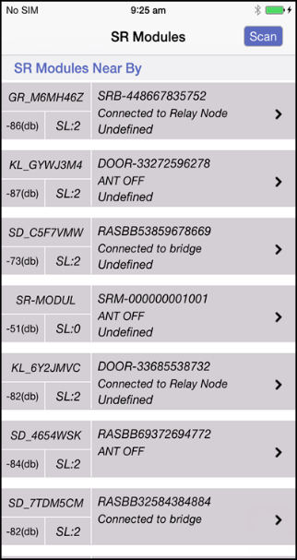 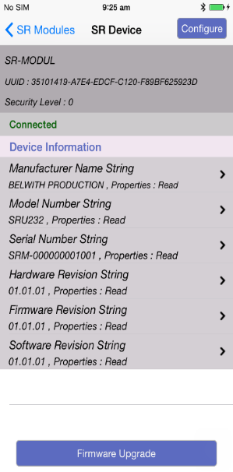

Figure # Figure #

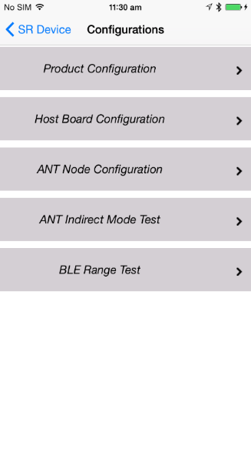 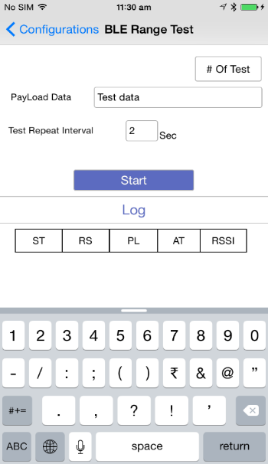

Figure # Figure #

* In Figure #4 first text box will display the # of tests which user performed.
* Second it will display Pay Load Data. User can enter any # of characters which he/she wants to test.
* In third text box user can enter the Interval time of Test Report.
* Then User press “Start” button.
* It will display the results in Log Window.
* In Log window it shows the results of ST (Start Time), RS (Response Time), PL (PayLoad Length), AT (Antenna) and RSSI.
* In AT (Antenna) there are two values will display: CA (Chip Antenna) or UA (uFL Antenna).

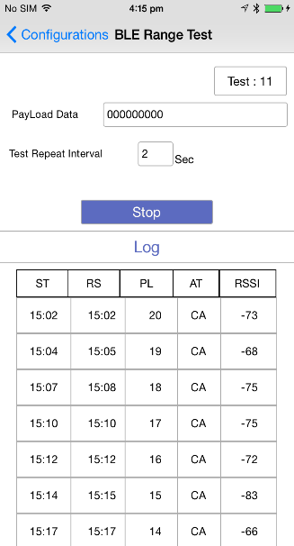

Figure #

## 4.3 Results

|  |  |  |
| --- | --- | --- |
| **Module :** | **SRU232** | |
| **Hardware Version** | 504_500041_HiLoFCCV2_01.01.03 | |
| **Firmware Version** | **Program SoftDevice** | SRU232.hex |
| **Program Application** | Stack_s310_nrf51422_1.0.0.hex |
| **Power Level** | ( -12 dBm ) | |
| **SR Smart Tool App Version** | **iOS** | 01.01.01 |
| **Android** | 1.1 |

|  |  |  |  |  |  |
| --- | --- | --- | --- | --- | --- |
| **Test Case Serial #** | **Device** | **Antenna Type** | **Height of Module from ground  Range in Connection mode** | | |
| **0.5 Meter** | **1 Meter** | **1.5 Meter** |
| **1** | **iPhone 4s** | **Chip Antenna** | 108 | 146 | 182 |
| **U.FL Antenna** | 85 | 213 | 213 |
| **2** | **iPhone 6** | **Chip Antenna** | 170 | 199 | 290 |
| **U.FL Antenna** | 138 | 225 | 250 |
| **3** | **iPhone 6 Plus** | **Chip Antenna** | 108 | 181 | 190 |
| **U.FL Antenna** | 112 | 216 | 216 |
| **4** | **Nexus 7** | **Chip Antenna** | 123 | 166 | 192 |
| **U.FL Antenna** | 121 | 167 | 237 |
| **5** | **Galaxy S5** | **Chip Antenna** | 150 | 180 | 210 |
| **U.FL Antenna** | 137 | 182 | 240 |

# Range test between SRU232 to SRU232 (ANT Mode)

## 5.1 Requisite items

1. 2# of SRU232 module with SRH232 Host board
2. 2x AA Alkaline battery or 5V Adapter
3. (2x) External Antenna and u.FL cable assembly part number
4. Windows Application “SR Bridge Simulator -1.0”

## 5.2 Testing Procedure

1. Launch “SR Network Simulator” windows application on your PC. Refer Figure #5.
2. Select “COM Port” and “Baud Rate”.
3. Then Click on “Connect” button.
4. It will display ANT Serial# in screen 1 until SRU232 will out of network range. Refer Figure #6.
5. When SRU232 will out of network range then it will automatically disconnect and display in screen2. Refer Figure #6.
6. Communication log will be display in screen 3. Refer Figure #6.

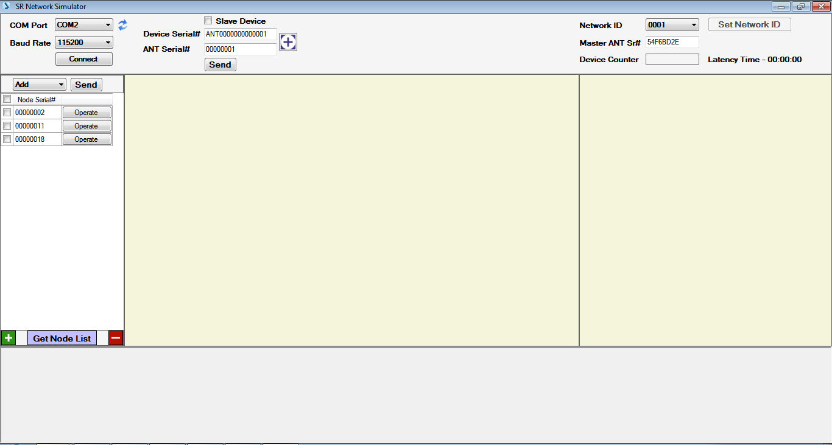

Figure #

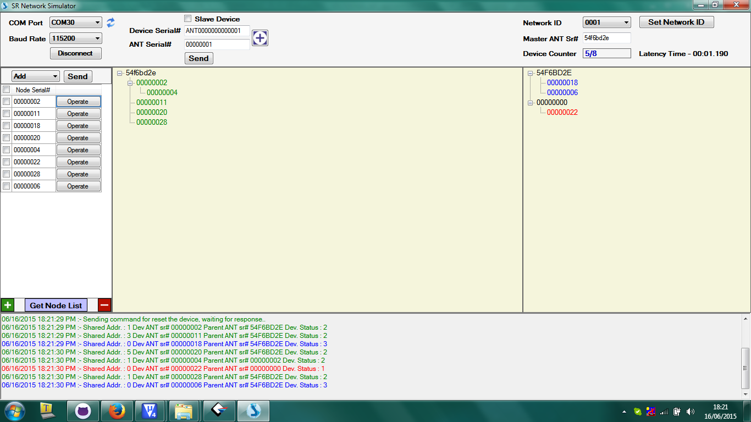

Screen 1 Figure # Screen 2 Screen 3

**In Network Range Not Registered in Network Out Range Device**

## 5.3 Results

|  |  |  |  |  |
| --- | --- | --- | --- | --- |
| **Module** | **SRU232 Master** | | | |
| **Hardware Version** | 504_500041_HiLoFCCV2_01.01.03 | | | |
|  |  | Type | Master | Slave |
| **Firmware Version** | **Program SoftDevice** | **Chip** | s310_nrf51422_1.0.0_softdevice.hex | |
| **U.FL** |
| **Program Application** | **Chip** | Matt_Master_Neg12Dbm_Chip.hex | Mat_Slave_Neg12Dbm_Chip.hex |
| **U.FL** | ANT_Master_12dbm_UFL.hex | Mat_Slave_Neg12Dbm_UFL.hex |
| **Power Level** | ( -12 dBm ) | | | |

|  |  |  |  |  |  |
| --- | --- | --- | --- | --- | --- |
|  | | | **Module** | SRU 232 Master | |
| **Serial Number** | **Module** | **Antenna Type** | **Height of Module from ground Range in Connection mode** | | |
|
| **0.5 Meter** | **1 Meter** | **1.5 Meter** |
| 1 | SRU 232 Slave | Chip Antenna | 152 | 193 | 248 |
| U.FL Antenna | 140 | 249 | 313 |

# Range test between Module to Module (BLE Mode)

## 6.1 Requisite Items

1. 2# of SRU232 module with SRH232 Host board

2. 2x AA Alkaline battery or 5V Adapter

3. (2x) External Antenna and u.FL cable assembly part number

4. Windows Application “SR Bridge Simulator -1.0”

## 6.2 Testing Procedure

1. For Range Testing, one SRU232 module worked as Central device and second SRU232 module worked as Peripheral device.
2. User needs 2x SRU232 module.
3. Give power supply to both SRU232 modules using 3.0V (2x AA) alkaline batteries or using 5V Adapter.
4. Set the SRU232 module (Central) and SRU232 module (Peripheral) at same height from ground (0.5m, 1m, 1.5m).
5. SRU232 module (Central) will continue scanning for SRU232 module (Peripheral) & try to connect with Peripheral device. In this scanning time, its display Green LED solid (D2 LED) in SRU232 module (Central).
6. When SRU232 module (Central) is successfully connected with SRU232 module (Peripheral) then in both SRU232 modules it will display Blue LED solid (D1 LED) till device is connected.
7. When the SRU232 module(Central) will disconnect from SRU232 module(Peripheral) then in both SRU232 module Blue LED will turn off & again in SRU232 module(Central) it will display Green LED solid(D2 LED) as an indication of scanning and again SRU232(Central) device will start scanning for peripheral device.
8. Now perform this test at different distance then repeat step #3 to step #7 again.
9. Find the maximum stable connection range of SRU232 module (Central) with SRU232 module (Peripheral) and note it down.
10. Repeat this test for different SRU232 modules and verify the results.

## 6.3 Results

|  |  |  |  |  |
| --- | --- | --- | --- | --- |
| **Module** | **SRU232 Master** | | | |
| **Hardware Version** | 504_500041_HiLoFCCV2_01.01.03 | | | |
| **Firmware Version** |  | Type | Central | Peripheral |
| **Program SoftDevice** | **Chip** | s110_nrf51822_6.0.0_softdevice.hex | |
| **U.FL** |
| **Program Application** | **Chip** | central_radio_test_-12dbm_MATT_Chip_ant_LED.hex | ble_app_peripheral_Radio_Test_V01.00.03.hex |
| **U.FL** | central_radio_test_-12dbm_MATT_UFL_LED.hex |
| **Power Level** | ( -12 dBm ) | | | |

|  |  |  |  |  |  |  |
| --- | --- | --- | --- | --- | --- | --- |
| **Serial Number** | **Module** | **Power Level** | **Antenna Type** | **Height of Module from ground** | | |
| **Range in Connection mode** | | |
| **0.5 Meter** | **1 Meter** | **1.5 Meter** |
| **1** | **SRU 232 Slave** | **( -12 dBm )** | **Chip Antenna** | 126 | 172 | 262 |
| **U.FL Antenna** | 182 | 237 | 265 |